AP Calc WS#16 Graphs and Derivative Name: ______
1. Relationship between the graph of f and f '
On your calculator set WINDOW (-5, 5)x(-10, 10). Graph function Y1 = x³ – 2x² – 5x + 6
Look at the graph, table and any necessary means, fill in the table below
 | A | B | C | D | F
Function characteristic | Increase  from ____ to | Maximum at  x = | Decrease  from ____ to | Minimum at  x = | Increase  from ____ to
Value of x | ? | ? | ? | ? | ?

Now ungraph Y1 (un-highlight its equal signd, move the cursor to equal sign, press Enter)
You will graph the derivative of function Y1. At Y2, type
Y2 = nDeriv(Y1, X, X) Look in MATH 8 , VARS, Y-VARS, Function
Look at the graph, table and any necessary means of Y2, fill in the table below
 | A | B | C | D | F
Function characteristic | Positive  from ____ to | Zero at  x = | Negative  from ____ to | Zero at  x = | Positive  from ____ to
Value of x | ? | ? | ? | ? | ?
Now you will put two tables above together and find the relationship between f and f'
At column | A: value of  x: ? __to?__ | B value of  x =? | C value of  x: ? ___to ? ___ | D value of  x =? | F value of  x: ? __to? __
Function f
First derivative f'
Write your conclusion
Function is increasing if its derivative is ? _________________
Function is decreasing if its derivative is ? ________________
If the derivative is equal to zero (horizontal tangent), then the function is at ?___________
2. Write the relationship table for function f(x) = -x³ + 3x² + 5x + 200 with its derivative. Hint: You only need to look at the graph of its derivative.

At column | A: value of  x: ? __to?__ | B value of  x =? | C value of  x: ? ___to ? ___ | D value of  x =? | F value of  x: ? __to? __
Function f
First derivative f'
3. Sketch the graph of a function f that has the following properties:
a. f(0) = 0 b. the graph of f ' is shown c. f is continuous for all x.

4.

Vocabularies: Differentiable = Able to take derivative.
Recall Limit vs continuity (can draw a graph without lifting the pen)
If function is continuity then it has limit → graph; If function has limit,it MAYnot continuity→ graph
New learning:
If the function is differentiable then it is continuous → graph illustration? (smooth)
If the function is continuous, it MAY not differentiable → graph illustration? (cusp)
5. For the graph of the functions below, tell if it has limit, continuous, and differentiable at x → c

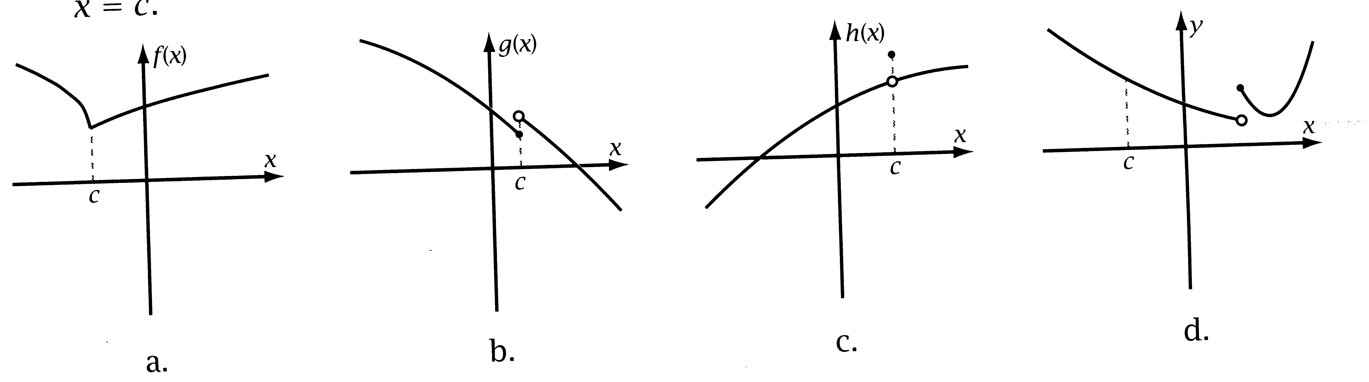
6. Let f(x) = ln(1 – x²). Find the domain of f and f '. Write the relationship table between them.

7. Given f'(x) sketch the graph of f(x)

8. Prove your work using algebra.

